**Green Society Public School**

**Ratnanagar-7, Sauraha, Chitwan**

**Second Terminal Examination-2082**

**Class: Nursery Time: - 2 hrs. F.M.: 50**

**Sub: Maths (O)**

1. What is your name? [5]
2. How are you? [5]
3. What is your school’s name? [5]
4. Say 1 to 20? [10]
5. Say ! - @) ? [10]
6. What is your class teacher’s name? [5]
7. Read the following numbers? [5]

**6 7 8 9 10**

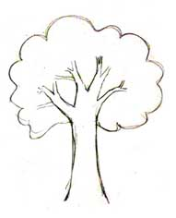 9. Identify the pictures. [5]





**The End**